**Project Design Phase-II Technology Stack (Architecture & Stack)**

|  |  |
| --- | --- |
| Date | 14 october 2022 |
| Team ID | PNT2022TMID27596 |
| Project Name | Project - university admit eligibility predictor |
| Maximum Marks | 4 Marks |

ABSTRACT

* The aim of this project is to help students in shortlisting universitieswith their profiles.
* The predicted output gives them a fair idea about their admissionchances to a particular university.
* This analysis should also help students who are currentlypreparing or will be preparing to get a better idea.
* For an aspiring graduate student, choosing which universities toapply to is really a difficult problem.
* Often, the students wonder if their profile is good enough for acertain university.
* University and College research being one part of the universityapplication process is itself an arduous and lengthy task.
* This issue being a big problem for students have not been solvedtill now. Hence, we have done this project to solve this issue.

OBJECTIVES

* College admission predictor is a boon to many students. This helps the student not only to help in filling out the application formsbut also give the students an idea about their future college by calculating their cut off.
* When students come from rural places , they find it hard to go along with the formal procedures. So, this application helps them alot and eases out their fear.
* Whatever may be their scores , this application helps to find the best colleges . Hence, our proposed computer aided system whichhelp the students to get the list of all colleges in which they could get the admission at the click of a button.
* The students only have to enter their marks of XII, AIEEE etc. Withthis application, the students can very easily obtain the list of colleges even branch wise and course wise. This will not only make the admission process easy but also minimizes stress for students . The main objective of our system is to make the right choice of colleges.
* Recommending best suitable universities to students based on their GRE, GPA and TOEFL scores and also predicting admissionprobability.

TECHNICAL ARCHITECTURE

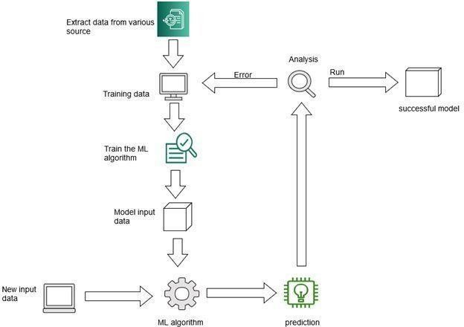

* 1. First, extract data from various source and
  2. Training the given data.
  3. Train the ML algorithm with the given data
  4. Model the input data
  5. Model input data are given to ML algorithm
  6. New input data are given to ML algorithm
  7. With the help of ML algorithm, prediction is performed
  8. This prediction is further analyzed
  9. While analyzing, if an error occurs the data is trained again10.If prediction analysis runs well then it is considered as a successful model

**Table-1 : Components & Technologies**:

|  |  |  |  |
| --- | --- | --- | --- |
| **S.No** | **Component** | **Description** | **Technology** |
| 1. | User Interface | How user interacts with application | HTML, CSS |
| 2. | Application Logic-1 | Logic for a process in the application | Python |
| 3. | Application Logic-2 | Logic for a process in the application | IBM Watson STT service |
| 4. | Application Logic-3 | Logic for a process in the application | IBM Watson Assistant |
| 5. | Database | Data Type (CSV FILE) | Kaggle website |
| 6. | Model of the data | Building model of the data | Machine learning |
| 7. | Libraries | Import libraries into data set | Pandas, Seaborn, Matplot lib, Numpy |
| 8. | Training and testing data | Purpose of data training and testing | Regression ,Classification, clustering Algorithms , SK learn |
| 9. | Testing Data | Tests data using Agile methodology | Agile methodology |
| 10. | Accuracy | Accuracy of the tested and trained data | Mean_squared_error, Mean_absolute_error |
| 11. | Infrastructure (Server ) | Application Deployment on Local System | Local. |

**Table-2: Application Characteristics:**

|  |  |  |  |
| --- | --- | --- | --- |
| **S.No** | **Characteristics** | **Description** | **Technology** |
| 1. | Open-Source Frameworks | List the open-source frameworks used | Flask framework |
| 2. | CSV file | Importing CSV file | Pandas |
| 3. | Data visualization | Perform data visualization | Matplot(pie charts,histograms) |
| 4. | Testing and Training | Create testing and training for the dataset | Technology used standardScaler, MinMaxScaler |
| 5. | Performance | Design consideration for the performance of the application | Technology used IBM wastson |